**Infrastructure for Busses**

**Developed by Vladislav Zhivkov**

**Assignment**

**To design and implement a database for BUS TRANSPORTATION, which will store the following information:**

* Schedule - destination, date, time, price, number, places;
* Client - name, phone number;
* Tickets - type, destination, price;
* Reservations - destination, date, time, price, employee;

**Rules:**

* Each customer can purchase/book more than one ticket
* There are many means of transport to each destination

**The database must be normalized and allow:**

1. **Data entry and corrections.**
2. **Search/Reverberations/Purchase tickets by destination, date, and time.**
3. **References to:**

* Sold tickets for a customer.
* Vacancies for destination/date/time.
* Sales for a period sorted by date.

**Top 5 ranking by the number of tickets per customer.**

**An explanatory note to the implemented project must contain:**

* **Models (Oracle Data Modeler)**
* **Sample Data**
* **SQL commands – DDL, DML**
* **Results of the execution of requests.**

**1. Tables Creation:**

1.1 Logical Model

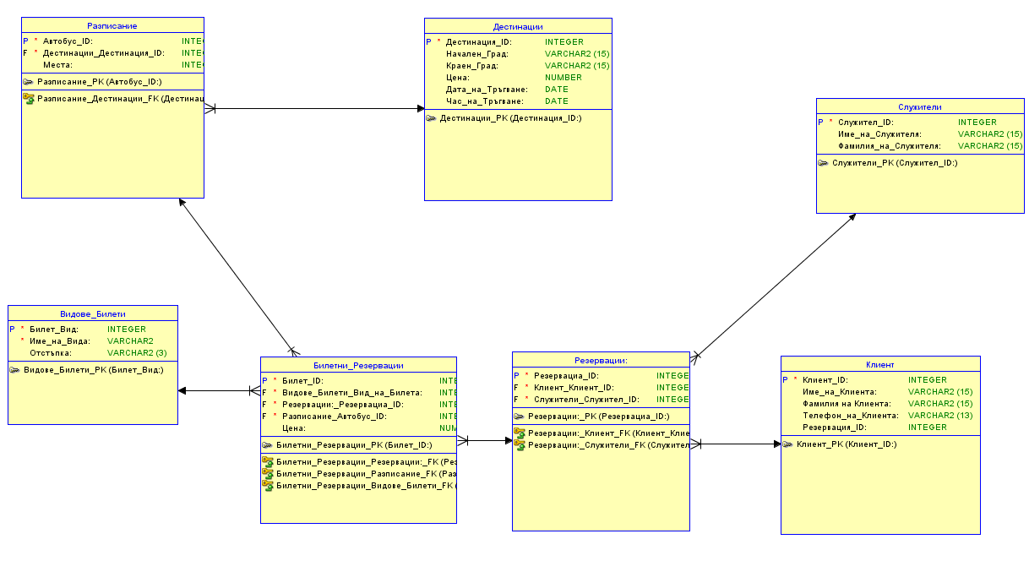

1.2 Relations Model

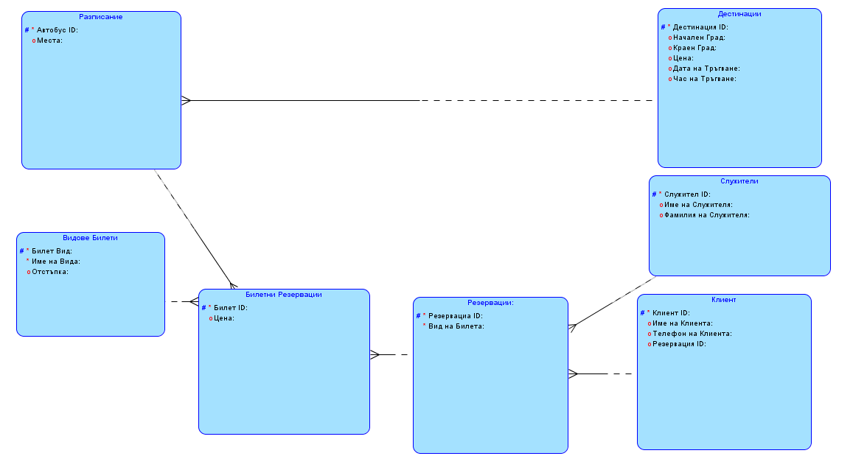

1.3 Development of the tables:

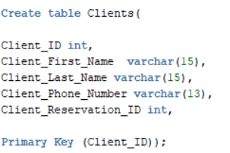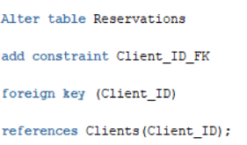

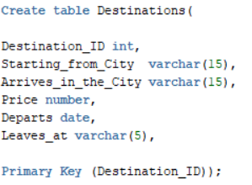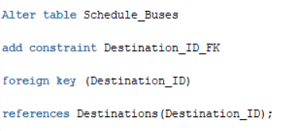

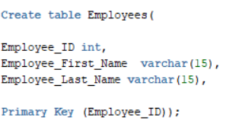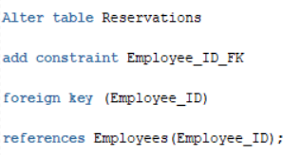

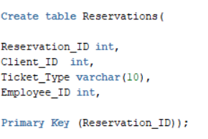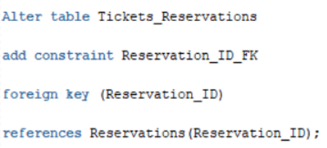

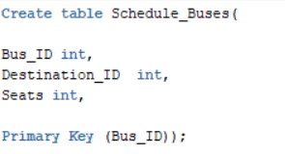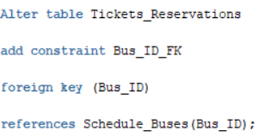

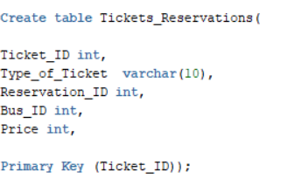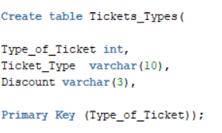

**2. Exemplary Data**

2.1 CLIENTS

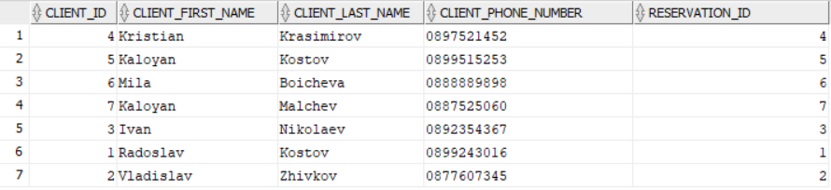

2.2 DESTINATIONS

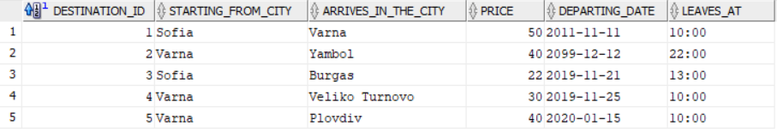

2.3 EMPLOYEES

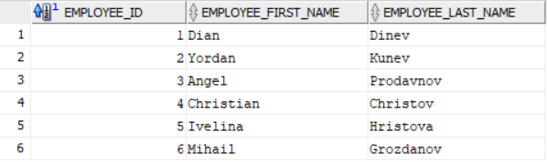

2.4 RESERVATIONS

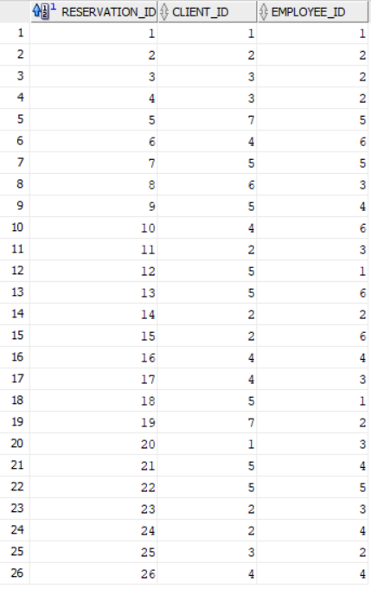

2.5 SCHEDULE_BUSES

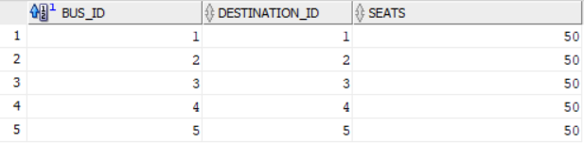

2.6 TICKETS_RESERVATIONS

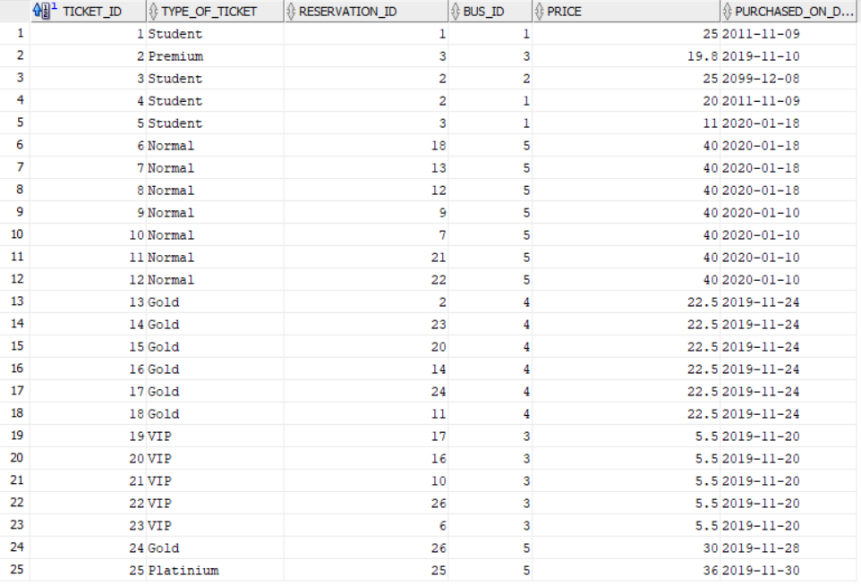

2.7 TICKETS_TYPES

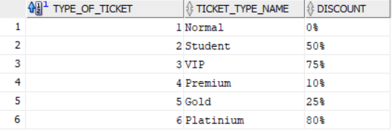

**1. Adding and updating the data:**

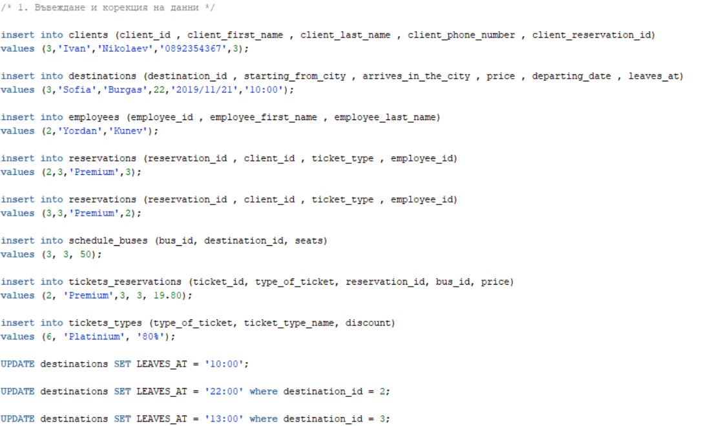

**2. Searches/Reservations/Purchases of tickets by destination, date, and time.**

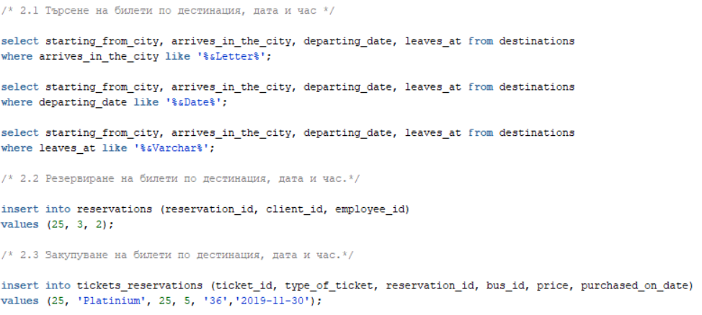

**3. References:**

3.1 Used commands:

3.1.1 Sold tickets per client:

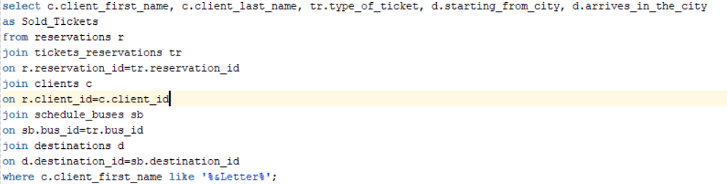

3.1.2 Free seats for destination/data/time:

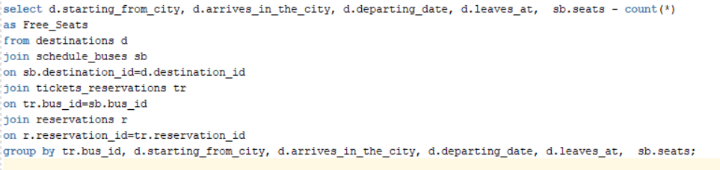

3.1.3 Sales for a period, sorted by dates:

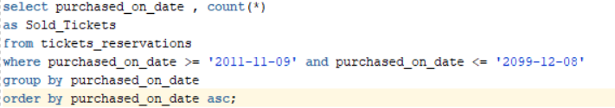

3.1.4 Top 5 rankings for sold tickets to a client:

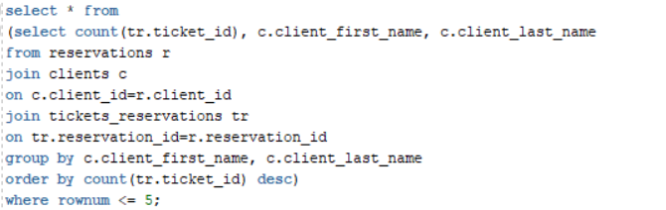

3.2 Results:

3.2.1 Tickets sold for a customer by Name:

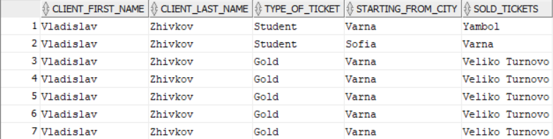

3.2.2 Free seats for destination/data/time:

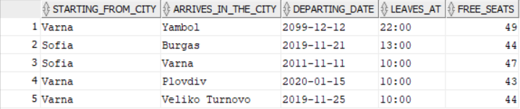

3.2.3 Sales for a period, sorted by dates:

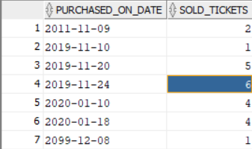

3.2.4 Top 5 rankings for sold tickets to a client:

